COMPUTER ENGINEERING DEPARTMENT

SUBMISSION REPORT
SUB: System Programming & Compiler Construction

COURSE: T.E. Year: 2020-2021 Semester: VI
DEPT: Computer Engineering
SUBJECT CODE: CSC602 SUBMISSION DATE: 19/05/2021
==========================================================================================

Name: Amey Thakur | Roll No.: 50
Class: TE Comps B | ID: TU3F1819127

INDEX

Sr.No. | Particulars | Submitted/Not Submitted or Enter Marks received
Experiments
1 | EXP 1: Develop a program to implement a lexical analyzer using Finite Automata. | 9/10
2 | EXP 2: implement Lexical Analyzer for given language using Lex tool. | 7/10
3 | EXP 3: To implement the program to remove left recursion from grammar and find first and follow the given grammar. | 8/10
4 | EXP 4: To implement any parsing technique. | 8/10
5 | EXP 5: To implement any code optimization techniques. | 8/10
6 | EXP 6: To generate target code. | 8/10
7 | EXP 7: To design and implement the first pass of a two-pass assembler for IBM 360/370 Processor. | 8/10
8 | EXP 8: To design and implement the second pass of a two-pass assembler for IBM 360/370 Processor. | 7/10
9 | EXP 9: To Design and Implement a two-pass Macro Processor. | 8/10
Assignments
13 | Assignment No. 1 | 10/10
14 | Assignment No. 2 | 10/10
15 | Assignment No. 3 | 10/10
Quizzes
16 | SPCC Quiz 1 | 10/10
17 | SPCC Quiz 2 | 10/10
18 | SPCC Quiz 3 | 10/10
19 | SPCC Quiz 4 | 10/10
20 | SPCC Quiz 5 | 10/10
21 | SPCC Quiz 6 | 10/10
IAT
22 | IAT-1 | 18/20
23 | IAT-2 | Submitted
Exit Survey
24 | Course Exit Survey | Submitted
25 | Laboratory Exit Survey | Submitted

Signature: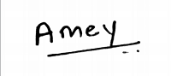

Experiments

SPCC Experiment 1
Marks: (9/10)
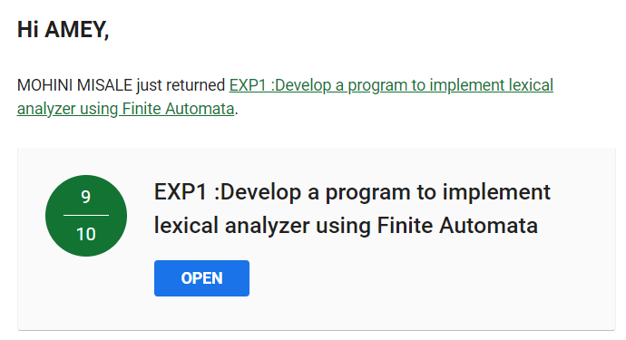

SPCC Experiment 2
Marks: (7/10)
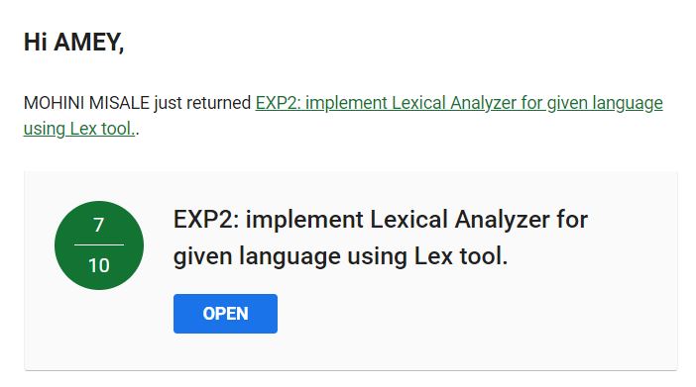
SPCC Experiment 3
Marks: (8/10)
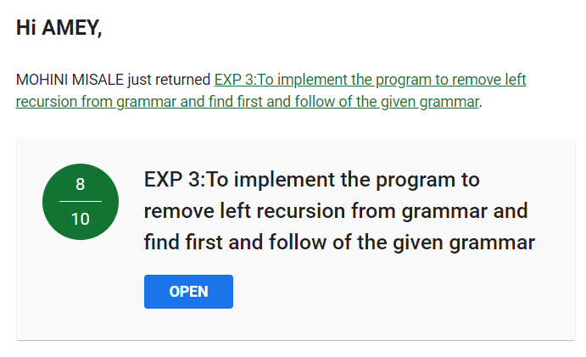

SPCC Experiment 4
Marks: (8/10)
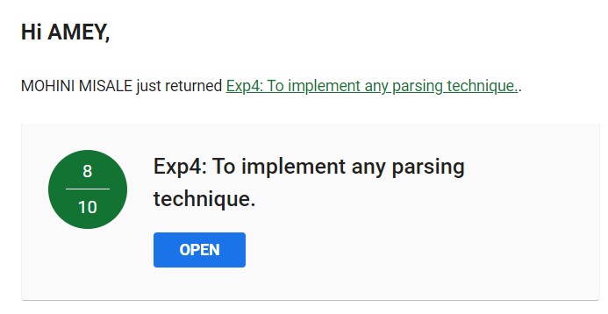

SPCC Experiment 5
Marks: (8/10)
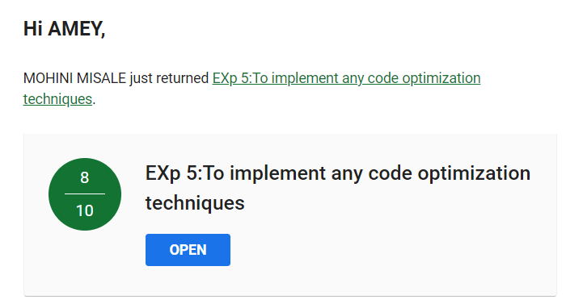

SPCC Experiment 6
Marks: (8/10)
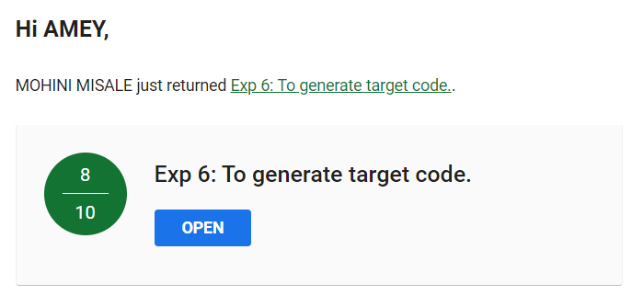

SPCC Experiment 7
Marks: (8/10)
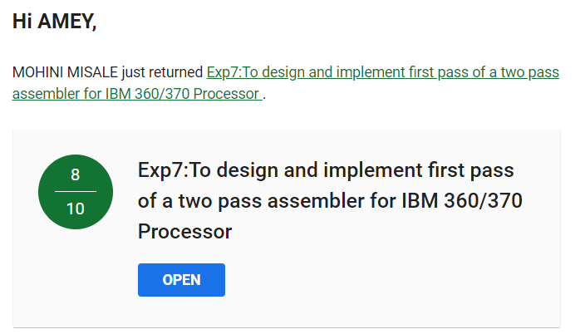

SPCC Experiment 8
Marks: (7/10)
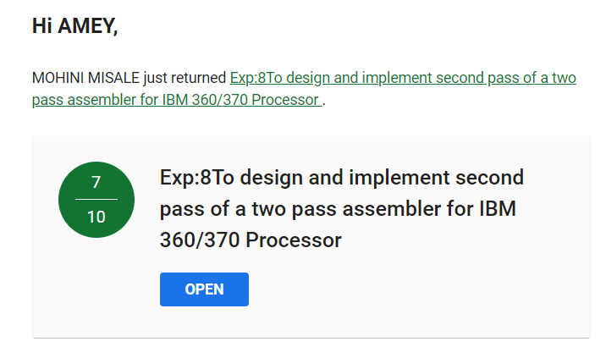

SPCC Experiment 9
Marks: (8/10)
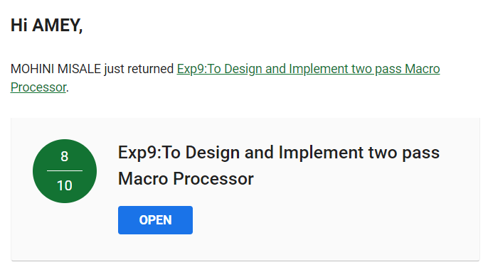

Assignments

SPCC Assignment 1
Marks: (10/10)
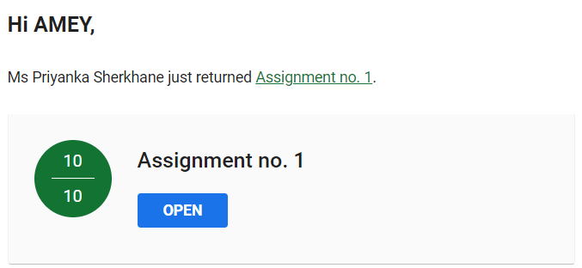

SPCC Assignment 2
Marks: (10/10)
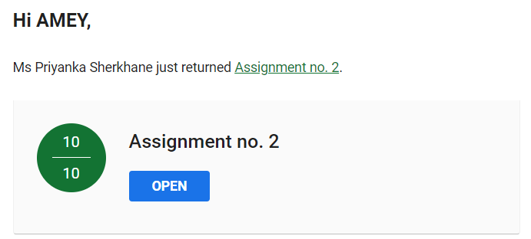

SPCC Assignment 3
Marks: (10/10)
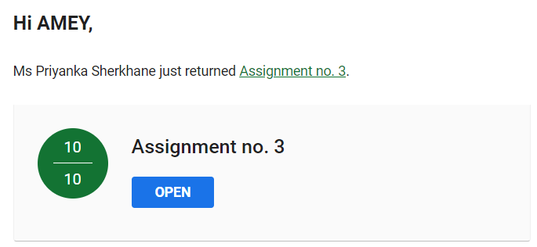

Quizzes

SPCC Quiz 1
Marks: (10/10)
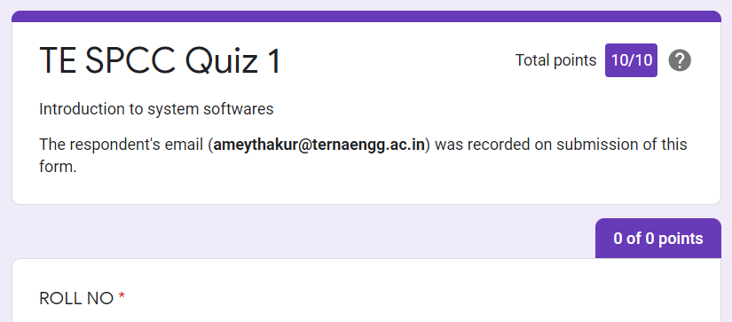
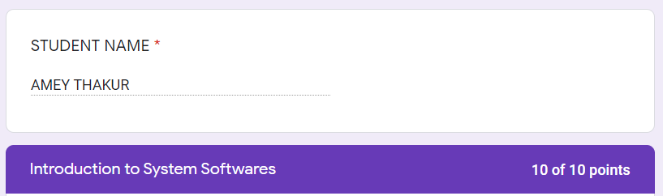

SPCC Quiz 2
Marks: (10/10)
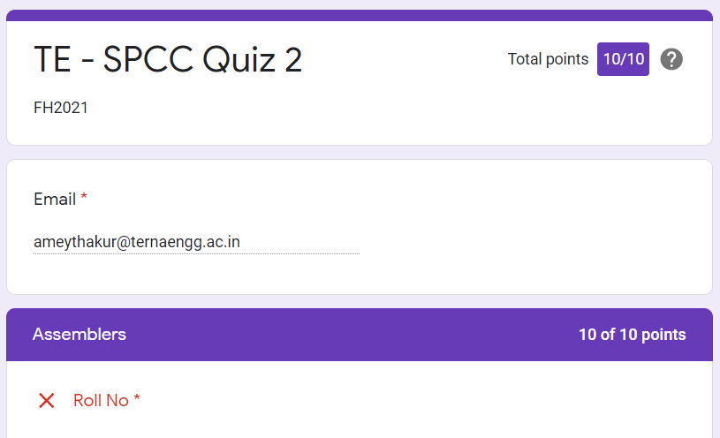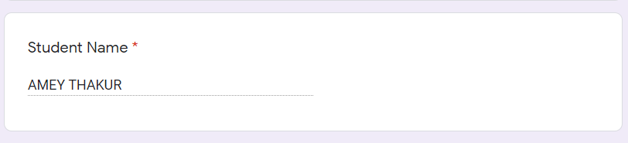

SPCC Quiz 3
Marks: (10/10)
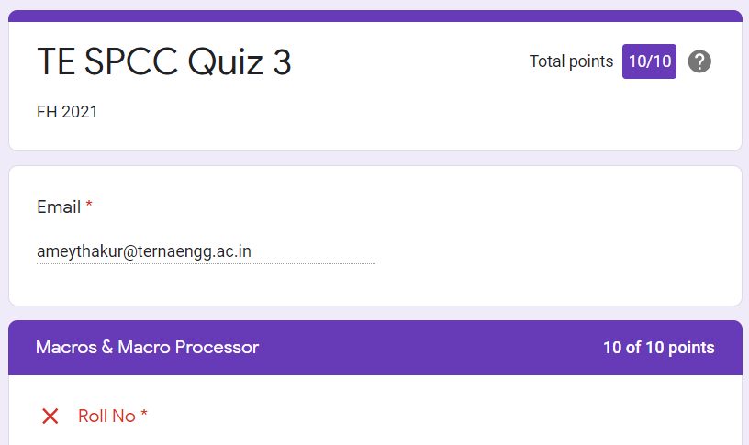

SPCC Quiz 4
Marks: (10/10)
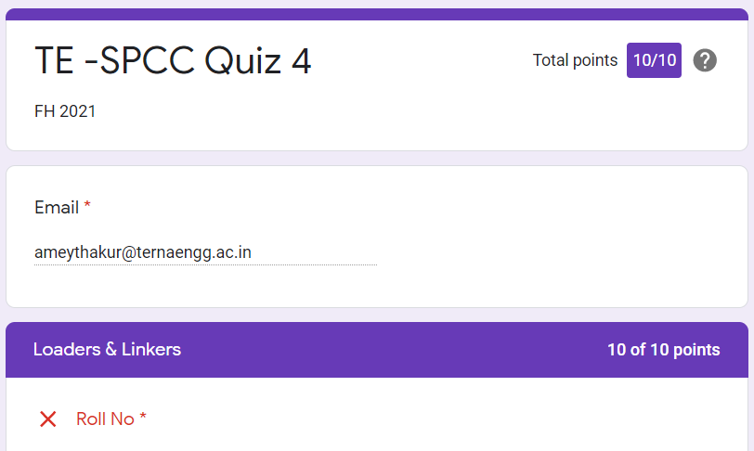

SPCC Quiz 5
Marks: (10/10)
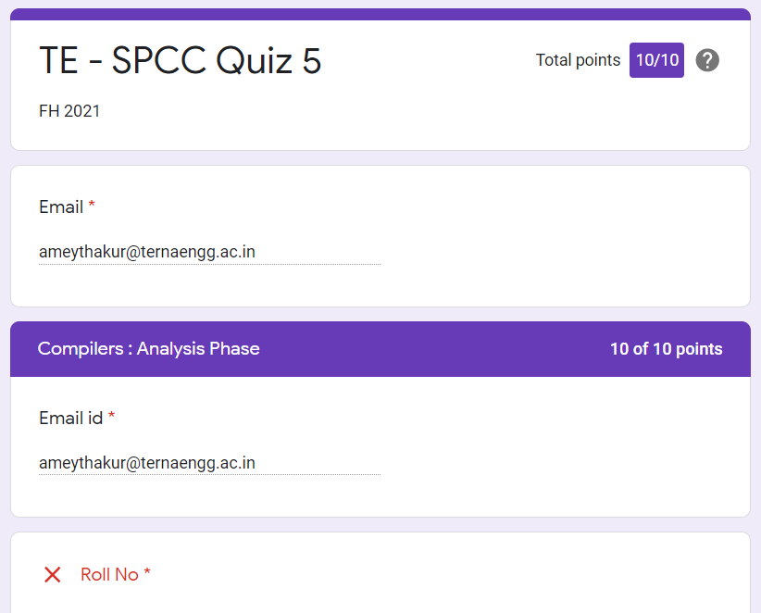

SPCC Quiz 6
Marks: (10/10)

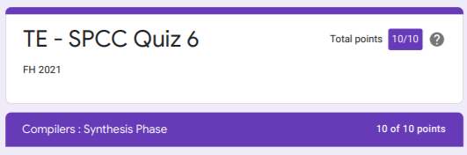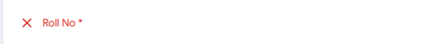

IAT

SPCC IAT 1
Marks: (18/20)
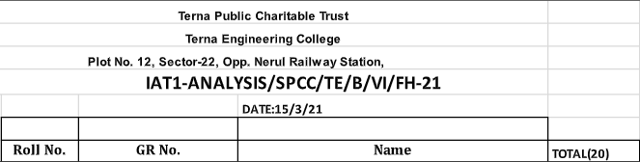

IAT 1 Descriptive Answer Sheet
(First page attached)
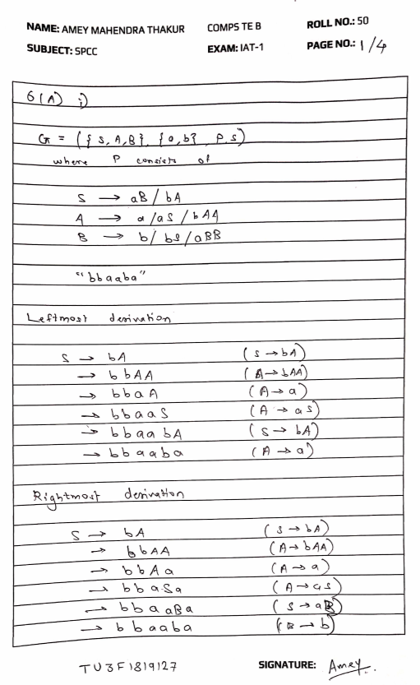
SPCC IAT 2
Marks: Not Received

IAT 2 Descriptive Answer Sheet
(First page attached)
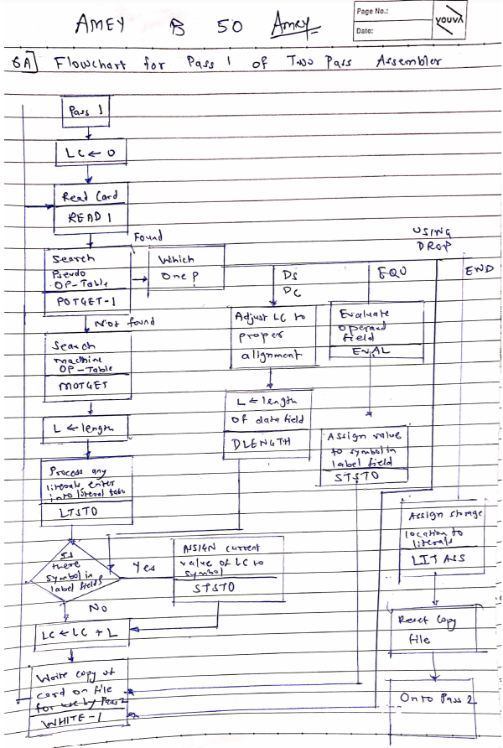
Exit Survey

SPCC Course Exit survey
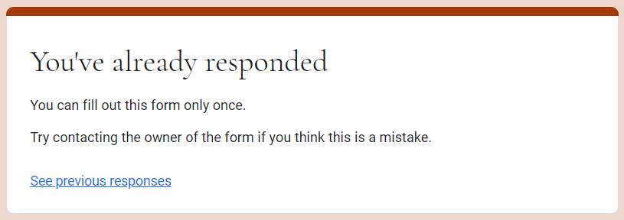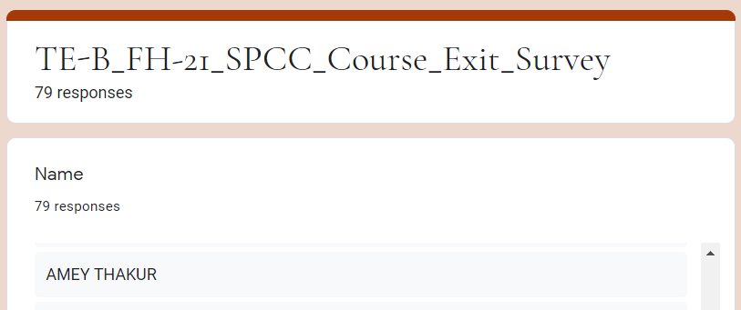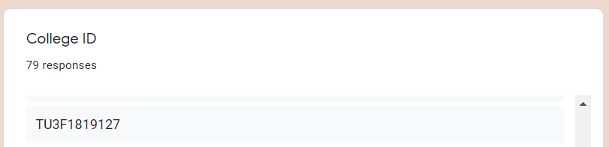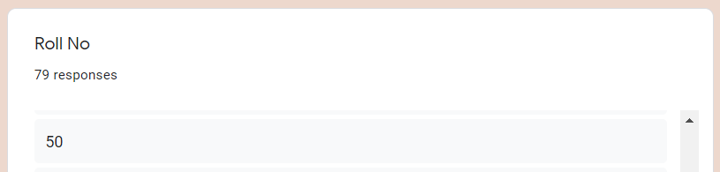
SPCC Laboratory Exit Survey
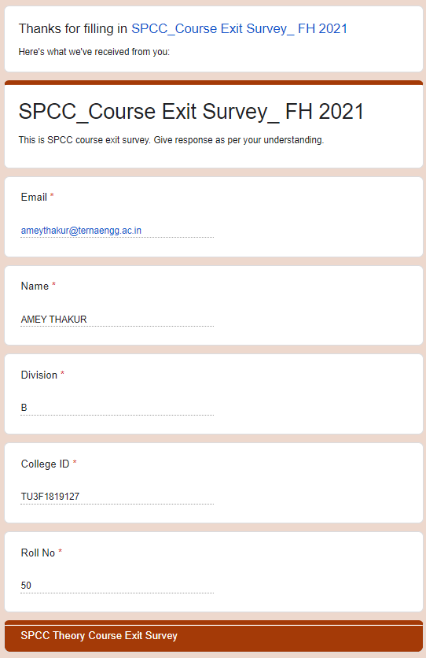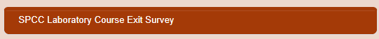
Google Classroom Submission Report
